6 Way Horizontally Mounted Rackmount 16A Commando PDU - UK Sockets (PDU-6WS-H-16CMDO)

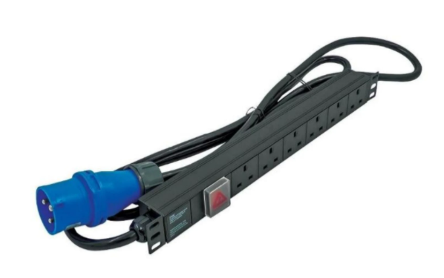

Description:
The LMS Power PDU-6WS-H-16CMDO is a high-quality horizontally mounted PDU (Power Distribution Unit) that simply fits within the universal mounting brackets of data, telecom and server cabinets.
A must-have accessory for your data cabinets if you need to provide effective power to devices including Ethernet Switches, Servers, UPS, NAS and of course cabinet accessories including cooling fan trays.
Robust, alloy design complete with rackmount brackets fitted, high-quality Neon Switch and of course UK output sockets together with a high quality, 16-Amp rated heavy duty Commando power input plug, ideal for industrial usage.

Key Features:
Standard UK 3-Pin power outlets for your appliances
HD Commando Plug for industrial applications
1U horizontally mounted attaches to internal profiles
Neon On/Off Rocker switch to prevent accidental turn off
Backed up by LMS Power's exclusive 3-year warrantyApplications:
Create instant power feeds to your data, telecom or server cabinets
Provide effective power for cabinet cooling fans, UPS systems
Ideal as stand-alone trailing sockets outside the cabinet

Product Code:
Part Number: PDU-6WS-H-16CMDO
EAN: 8400800036155
Weight: 1.3Kg approx

Technical Specifications:
Warranty LMS Data 3-Year Warranty
Chassis 1U horizontally PDU with mounting brackets
Output Sockets 6 UK 3-PIN Sockets
Power Input Fitted 16-Amp HD Commando Plug
Flex Length 1.8 metres (approx)
Power Control On/Off Rocker Switch (illuminated)
Power Rating 4000 Watts (approx) Surge Protected

Supplied With:
PDU-6WS-H-SP-16CMDO 6 Way Horizontal PDU
Cabinet brackets (Fitted)
* Specifications and product design are subject to change. E&OE.

Looking for highperformance power distribution for your heavily loaded systems? The newly developed LMS Data 16A heavy-duty horizontal high-density PDU is ideal for high-loading device requirements including server, network and other industrial-type equipment functions such as broadcast and HVAC applications. Combining a fully certified commando type 16A plug input combined with a compatible heavy load power flex means you can be assured this LMS Data PDU can work without problems, 24/7. Furthermore, incorporated onto the horizontal form-factor are standardised, UK 3-pin plug sockets. Ideal for connection to ethernet switches, NAS devices, Servers and of course other active products with the added benefit of electrical surge protection. Robust in design, with an integral neon illuminated rocker switch for assured functionality, the LMS Data PDU is designed to deliver maximum electrical power today and tomorrow.

specifications:
Horizontal, high-density Power Distribution Unit (PDU)
Heavy-load 16A Commando style 3-pin plug
Compatible, heavy-load power cable
6x standardised UK output power sockets
Robust, black aluminium design for industrial use
Neon on/off power switch for assured control
Maximum power rating - 4000W nominal
2.0 metre (approx.) power cordage

